General Description

  - Product Perspective
This system will consist of two parts: one mobile application and one web portal. The mobile application will be used to find restaurants and view information about them while the web portal will be used for managing the information about the restaurants and the system as a whole.
The mobile application will need to communicate to a GPS application within the mobile phone, which in turn communicates with a physical GPS device to find the location of the user, see Figure 1. The GPS will provide the mobile application with locations of both the user and the restaurants and the distance between them, but it will also provide maps and the functionality to display the application’s data on the map. The functionality provided by the GPS will be embedded into the application in order for the user to be able to use the functions in the application in a seamlessly manner.
Since this is a data-centric product it will need somewhere to store the data. For that, a database will be used. Both the mobile application and web portal will communicate with the database, however in slightly different ways. The mobile application will only use the database to get data while the web portal will also add and modify data. All of the database communication will go over the Internet.
The mobile application has some restrictions about the resource allocation. To avoid problems with overloading the operating system the application is only allowed to use 20 megabytes of memory while running the application. The maximum amount of hard drive space is also 20 megabytes.
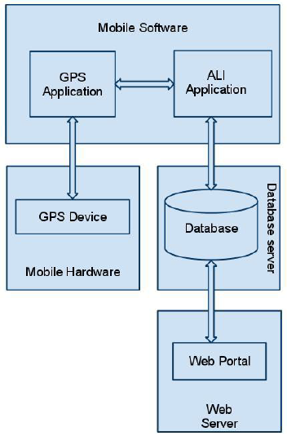
Figure 1 - Block Diagram
  - Product Functionality
With the mobile application, the users will be able to search for restaurants. The result will be based on the criteria the user inputs. There are several search criteria and it will be possible for the administrator of the system to manage the options for those criteria that have that.
The result of the search will be viewed either in a list view or in a map view, depending on what criteria included in the search. The list view will have one list item for each restaurant matching the search criteria and show a small part of the restaurant information so the user can identify the restaurant. The map view will show each restaurant location as a pin on the map as well as the user’s own location. In both views the users will be able to either select a restaurant as target destination or get information how to get there, or view the information of a specific restaurant.
The web portal will provide functionality to manage the system and the restaurant information. It will also provide information about the system, for example show when there is a new update.

  - Users Characteristics
There are three types of users that interact with the system: users of the mobile application, restaurant owners and administrators. Each of these three types of users has different use of the system so each of them has their own requirements.
The mobile application users can only use the application to find a restaurant. This means that the user have to be able to search for restaurants, choose a restaurant from that search and then navigate to it. In order for the users to get a relevant search result there are multiple criteria the users can specify and all results matches all of those.
The restaurant owners will not use the mobile application but the web portal instead. There they will manage the information about their restaurant, for example a description of the restaurant, contact information and their menu.
The administrators also only interact with the web portal. They are managing the overall system so there is no incorrect information within it. The administrator can manage the information for each restaurant as well as the options for both the mobile application users and the restaurant owners.

  - Assumptions and Dependencies
One assumption about the product is that it will always be used on mobile phones that have enough performance. If the phone does not have enough hardware resources available for the application, for example the users might have allocated them with other applications, there may be scenarios where the application does not work as intended or even at all.
Another assumption is that the GPS components in all phones work in the same way. If the phones have different interfaces to the GPS, the application need to be specifically adjusted to each interface and that would mean the integration with the GPS would have different requirements than what is stated in this specification.

  - Constraints
The mobile application is constrained by the system interface to the GPS navigation system within the mobile phone. Since there are multiple system and multiple GPS manufacturers, the interface will most likely not be the same for every one of them. Also, there may be a difference between what navigation features each of them provide.
The Internet connection is also a constraint for the application. Since the application fetches data from the database over the Internet, it is crucial that there is an Internet connection for the application to function.
Both the web portal and the mobile application will be constrained by the capacity of the database. Since the database is shared between both applications it may be forced to queue incoming requests and therefor increase the time it takes to fetch data

